KINDERMUSIK REGISTRATION
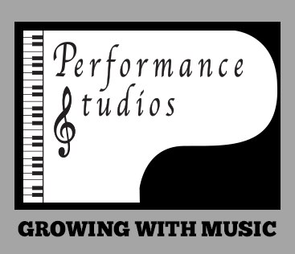
All classes are on a first come first serve basis – DON’T BE DISAPPOINTED
A deposit of $50(non-refundable) to hold your spot with balance to be paid at the first class

If a class is cancelled another will be re-scheduled. We require 5 students for a class to start. Please call to advise if you are unable to attend class or have questions concerning your child’s musical experience.

STUDENT NAME: _____________________________________________________
BIRTHDATE: ___________ GRADE IN SCHOOL in Sept. (if applicable) _______________
PARENT’S NAME: __________________________________________________________
ADDRESS: __________________________________________P.C.____________________
PHONE (Home) _________________ (Work) ______________Email__________________
Cell Phone _______________ Which is the best way to contact you? ________________
INSTRUMENT AT HOME _______________
HOW DID YOU HEAR ABOUT US? (Please circle):
Facebook Instagram Word of Mouth Sign Internet search
IS THERE ANYTHING SPECIAL THAT WE SHOULD KNOW ABOUT YOUR CHILD? ________________________________________________________________________

OUR TIME(all ages up to 5)
45 minute class
Materials include:
40 page home activity book, 2 CDs, 2 movement and storybooks and instrument
Total cost per child for 15 week semester
Circle date(s): Tuesday 9:30 am - Wednesday 9:30 am
Class __________Day _________ Time ____________
Cost: $???

----------------------------------------------------------------------------------------------------------------

Send To: Performance Studios
595 St. George St. East
Fergus, Ontario
N1M 1L1

Method of payment: Cash - Cheque – E-Transfer

Amount Paid: _________

519-843-3517

